INTERNSHIP & MINI-PROJECT MATCHBOARD
@CREATIVITY THINK (9483175986/7019689991)

ABSTRACT:
Internship & Mini-Project Matchboard is a dynamic web-based application designed to connect students with relevant internships and academic mini-projects. The platform enables students to create detailed profiles, browse opportunities, apply, track application status, and share feedback upon completion. Colleges and companies can post openings, manage applicants, shortlist suitable students, and monitor progress. Developed using Django REST Framework and React with Redux, the system provides a structured, transparent, and analytics-driven interface that streamlines the student–opportunity matchmaking process..

INTRODUCTION OF THE PROJECT:
In academic environments, finding the right internship or mini-project is often time-consuming and unorganized. Students rely on fragmented communication channels, while institutions struggle to track participation, progress, and outcomes.
The Internship & Mini-Project Matchboard centralizes this entire workflow by providing an end-to-end digital system. Students can build their profiles, apply for suitable opportunities, and maintain a portfolio of completed work. Administrators can easily post openings, track applications, manage shortlisting, and generate analytics reports to evaluate engagement across domains and batches..

PROJECT OBJECTIVES:

• Provide a centralized matchboard for internships and mini-projects
• Allow students to create profiles, upload skills, and showcase achievements
• Display categorized opportunity listings with filters and search
• Support application management and status tracking
• Allow students to add completed work to their portfolio
• Enable admins to post opportunities and shortlist applicants
• Provide dashboards with analytics for domain-wise and batch-wise metrics
• Export participation, status, and completion reports
• Improve transparency and reduce manual administrative workload

PROBLEM OF THE STATEMENT:
Institutions often face difficulty organizing internships or mini-projects due to scattered communication, limited tracking, and lack of analytics. Students struggle to find suitable opportunities aligned with their skills and academic goals. Without a structured platform, shortlisting, monitoring, and documentation become inefficient.
This system solves these problems by offering a unified digital matchboard that simplifies posting, applying, tracking, and reviewing all opportunities..

MOTIVATION OF THE PROJECT:
• To create a seamless connection between students and opportunities
• To eliminate manual processes used by colleges and training institutes
• To help students maintain a professional project portfolio
• To provide institutions with detailed analytics and progress reports
• To enhance transparency in the selection and completion process
• To reduce communication gaps between students, staff, and companies
• To support structured academic and skill-based development

BLOCK DAIGRAM OF PROJECT:

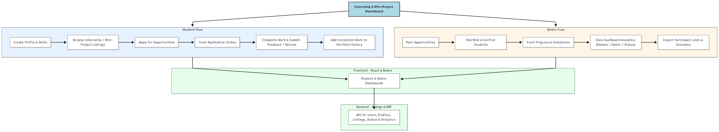

WORKING OF THE PROJECT:
Students begin by creating a profile that includes skills, academic details, and project preferences. They can browse available mini-projects and internships posted by colleges or companies.
After applying, students can track their application status such as Applied, Shortlisted, Selected, In-Progress, or Completed. Upon finishing the work, they can submit reviews and store their output in their personal portfolio.
Administrators can post opportunities with details like domain, required skills, duration, and batch eligibility. They can review applicants, shortlist candidates, monitor progress, and update statuses.
A powerful dashboard displays analytics such as number of applicants per domain, completion statistics, and batch-wise distribution, helping institutions evaluate participation and performance. Export tools allow downloading participant data and outcome reports..

SOFTWARE REQUIREMENT:
- Backend:
  - Python 3.x
  - Django
  - Django REST Framework
  - SQLite/PostgreSQL
- Frontend:
  - Node.js and npm
  - React.js
  - Axios
- Development Tools:
  - Visual Studio Code
  - Postman (for testing APIs)
  - Git/GitHub (for version control)
- Server/Deployment (Optional):
  - Gunicorn, Nginx, or Heroku/AWS for hosting

ADVANTAGES OF THE PROJECT:

• Streamlines the internship/project selection workflow
• Provides equal opportunity visibility to all students
• Reduces manual workload for institutions
• Tracks applications with complete transparency
• Helps students build a long-term digital portfolio
• Provides analytics for academic evaluation and planning
• Simple and fast dashboards for both students and admins
• Enhances communication between colleges, companies, and students

APPLICATIONS OF THE PROJECT:
• Engineering and degree colleges
• Training institutes
• Skill development centers
• Startup internship programs
• Academic project coordination teams
• Placement and training departments

REFERENCES:

- Django REST Framework Documentation — Django Software Foundation. Django Documentation. Available: https://docs.djangoproject.com/
- Django REST Framework. DRF Documentation. Available: https://www.django-rest-framework.org/
- React. React Official Documentation. Available: https://reactjs.org/docs/getting-started.html
- Redux. Redux Documentation. Available: https://redux.js.org/introduction/getting-started
- PostgreSQL Global Development Group. PostgreSQL Documentation. Available: https://www.postgresql.org/docs/
- MySQL. MySQL Reference Manual. Available: https://dev.mysql.com/doc/
- Git. Git Documentation. Available: https://git-scm.com/doc
- Node.js. Node.js Documentation. Available: https://nodejs.org/en/docs/
- Axios. Axios Documentation. Available: https://axios-http.com/docs/intro
- Socket.io Documentation – https://socket.io/docs/

